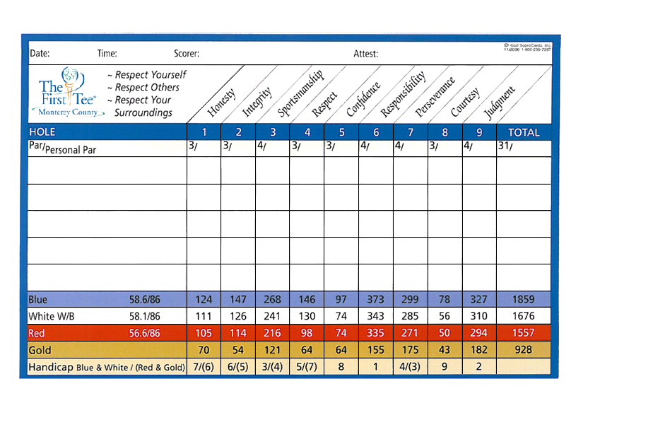



1551 Beacon Hill Drive, Salinas CA 93905

831-444-7200 ext 216

WWW.Thefirstteemc.org

1551 Beacon Hill Drive, Salinas CA 93905

831-444-7200 ext 216

WWW.Thefirstteemc.org

1551 Beacon Hill Drive, Salinas, CA 93905

831-444-7200 ext 216 • www.thefirstteemc.org

1551 Beacon Hill Drive, Salinas, CA 93905

831-444-7200 ext 216 • www.thefirstteemc.org